HCD6815 Compact Weather Station
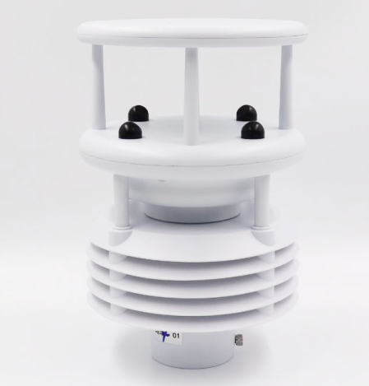

HCD6815 is designed and produced by Handan Yunnong Intelligent Agricultural Technology Co., Ltd and usded to measure various meteorological parameter. It innovatively realizes the five meteorological standard parameters (environmental temperature, relative humidity, wind speed, wind direction and atmospheric pressure) through a highly integrated structure, which can realize the 24-hour continuous online monitoring of outdoor meteorological parameters, and output the five parameters to the user at one time through the digital communication interface.In addition, It can be expanded to increase other meteorological and environmental parameters (rainfall, sunshine radiation, AQI six parameters: CO, NO2, SO2, O3, PM2.5, PM10). Output is RS485(MODBUS protocol)

FEATURES

*Quality Measurements *Real Time Output
*Lightweight and Robust *Easy installation
*High accuracy and stable performance * Customer Support
*Compact Integrated Design *Free of charge Software
*Low Power Mode *1 Year Warranty

APPLICATIONS

*Building and Industrial Controls *Authorities *Transport *Coastal

*Agricultural *Safety * Educational *Commercial *Energy

Measture item | Principle | Range | Resolution | Accuracy
Atmospheric temperature | Energy gap method | -40-60℃ | 0.1℃ | ±0.3℃（25℃）
Atmospheric humidity | Capacitance method | 0-100%RH | 0.01% | ±3%RH
Atmospheric pressure | Piezoresistive | 300-1100hpa | 0.01hpa | ±0.5hpa（0-30℃）
Wind speed | Ultrasonic | 0-60m/s | 0.01m/s | （（0-30m/s）±0.3m/s or ±3%
Wind direction | Ultrasonic | 0-360° | 0.1° | ±2°
Supply | 12-24VDC, solar power
Output | RS485(Modbus)
fixed form | Sleeve fixed
Power consumption | ＜1W@12V
Ingress Protection | IP66
Main material | ASA+engineering plastics
Mounting frame | 1.5m, 3m Flange, 1.8m tripod
GPS | Device tracking and positioning
Data Release | PC、Telephone APP、LED、LCD TV display, etc
TECHNICAL SPECIFICATION

WIRING METHOD
HCD6815 Wiring
Red line | Positive pole（DC12V - DC24V）
Black line | Negative pole（DC12V - DC24V）
Yellow line | RS485 A
Blue line | RS485 B

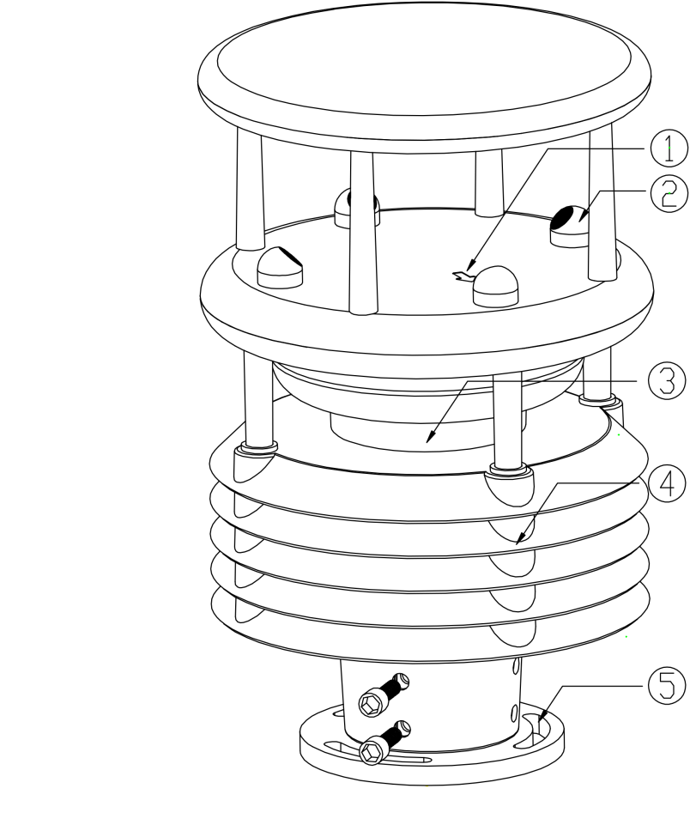
- Arrows to point north
- Ultrasonic probe
- Control circuits
- Thermometer shelter (temperature, humidity, air pressure monitoring position)
- Bottom fixed with flange
※This product can be equipped with electronic compass, GPRS(built-in)/GPS (optional)

